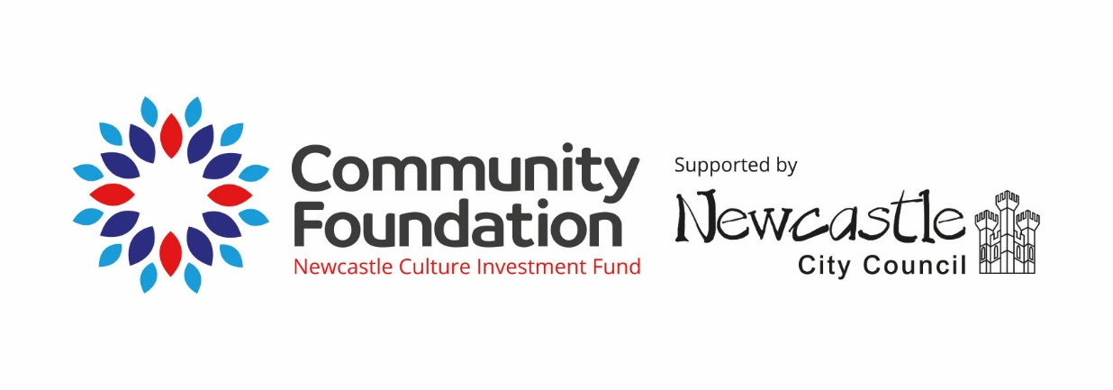

The Newcastle Culture Investment Fund is a grant programme for independent organisations in the Newcastle City Council area, who are delivering culture and encouraging the creative expression of communities. Funds are awarded to organisations that can show they are contributing to the new Cultural Strategy for the city (2022-30)

**We are currently seeking applications for projects taking place in 2025-26**

**About the Grants**

We are looking to fund projects and programmes which enable the creativity and imagination of people in Newcastle. We welcome applications from both community organisations and arts organisations. Applications from community organisations should be able to demonstrate strong partnerships with artists and/or cultural organisations. All organisations must arrange a preliminary chat with the Fund Manager before making an application.

The Newcastle Culture Investment Fund projects round has £90,000 a year to distribute. It is open now on a rolling basis and will be available until all the funds have been allocated.

Grants are intended to support project costs for activity that is planned to start in this financial year. The majority of costs should relate to activity, but proportionate additional salary costs are accepted. Organisations can bid for a minimum of £1000 and a maximum of £12,000.

Please take the time to read the general Community Foundation guidance notes and information thoroughly. They can be found [here.](https://www.communityfoundation.org.uk/apply/)  If your organisation is a Community Interest Company (CIC) please pay special attention to that guidance.

**Fund Specific Eligibility Criteria**

* The fund is only open to applications from cultural and community organisations delivering cultural activity in the Newcastle City Council area. Organisations that are registered outside of Newcastle but can demonstrate a commitment and presence in the city will be considered, albeit as a lower priority.
* Organisations can only apply once.
* Applicant organisations must be run independently of local and national government
* Applicant organisations must have been established and operating for at least one year and have at least one set of audited or independently examined accounts.

We will not support:

* Organisations awarded core funding for 2025-28
* Organisations physically based (ie with a venue that is open to the public) outside the Newcastle City Council area, even if some of the work they deliver is within Newcastle. If your organisation is registered outside of Newcastle for administrative purposes, but the work you do is wholly in the city area, then we can consider an application.
* Applications from individuals and freelancers, although we encourage organisations to reference how they engage them within their applications.
* Activities or core costs that are already financed through other funders or via earned income.
* Capital work

**Repeat applications**

We review every application and make recommendations for support based on several factors. These include

* the overall portfolio to ensure we have a balance between artform, beneficiary group or geography.
* the sector’s need for longer-term funding for established initiatives alongside support for new projects. This means that whilst we will accept applications for repeat funding, only applications showing significant project development will be considered. ‘Significant project development’ includes, for example, new delivery models, capacity-building for increased creative delivery (such as CPD for teachers), or a response to newly identified needs.

In exceptional circumstances, if an organisation can demonstrate they are the **sole** provider of a creative service in the city an application for ongoing funding for an established project may be appropriate.

In all cases, particular attention will be paid to future sustainability, such as upskilling partners and/or exploring other income streams. A preliminary conversation with the fund manager should be arranged **before** making a repeat application.

**How to Apply**

In this round we want to see projects that embody and enliven the Newcastle’s Cultural Strategy.

The full strategy can be found on the Newcastle Creates website: <https://www.newcastlecreates.co.uk/our-plans/>

The Cultural Strategy summarise 6 ‘Themes and Ambitions’ which are:

* Equality, Diversity & Inclusion
* Prosperity
* Opportunity
* Place
* Health & Wellbeing*
* Climate

Alongside the completed application form, an additional document must be uploaded that makes a case for support with explicit reference to the Cultural Strategy.

*All applications must reference how they contribute to the success of the Health & Wellbeing theme and one other identified ambition from the list above.

This document must be no more than 1 A4 page (font size 12).

**How decisions are made and timelines**

The Foundation has appointed an independent Fund panel, which includes one Newcastle City Councillor, a member of the Newcastle City Culture Compact as well as other independent members who are in the majority. The Chair is one of the independent members.  The Foundation will award grants from the Fund on the basis of the panel’s recommendations.

We aim to communicate the decisions within 12 weeks of submission.

All awards are subject to receiving the funds from Newcastle City Council. This is a rolling programme and we will continue to accept applications until the fund balance has been spent.

**How to apply**

This is an online application process available via our website. **Organisations are reminded that a preliminary chat with the fund manager and submission of a supporting statement aligning to the cultural strategy are an essential part of the process**.